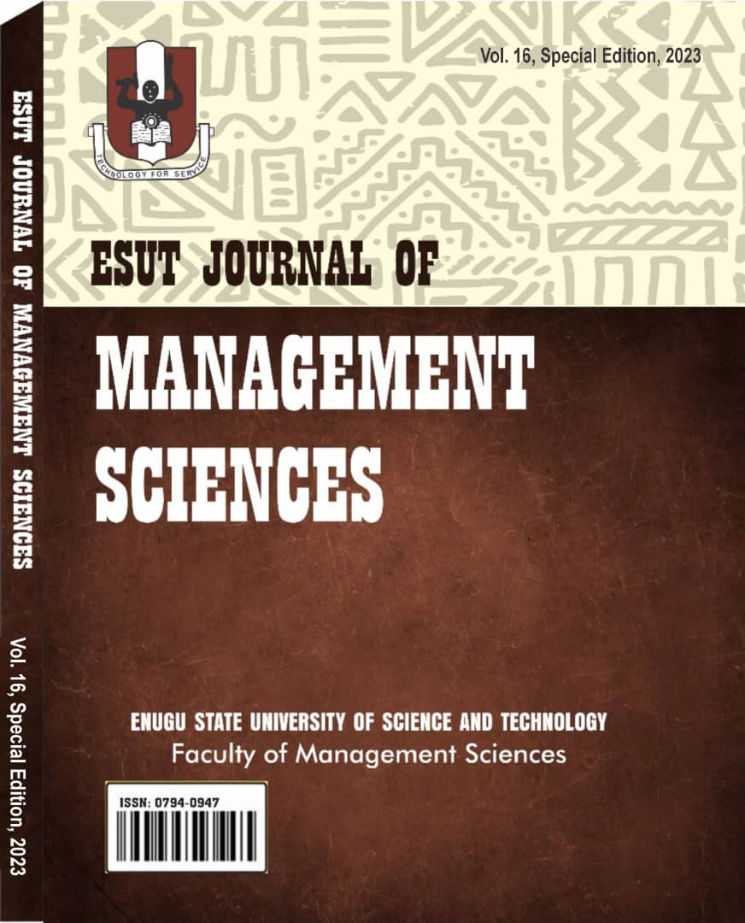

# ESUTJMS EDITORIAL BOARD

## Editor-in-Chief

Prof. Chioma D. Oleka

Dean, Faculty of Management Sciences, Enugu State University of Science and Technology (ESUT) Enugu, Enugu State.

## Editor at Large

Prof. Chike Nwoha

Deputy Vice Chancellor, ESUT and former Dean, Faculty of Management Sciences.

## Deputy Editor-in-Chief

Prof. Chris C. Ngwu

Department of Mass Communication, Enugu State University of Science and Technology (ESUT) Enugu, Enugu State.

Chelasuniverse@yahɔo.com

## Editor

Dr. Ekwe Okwudiri

Department of Mass Communication, Enugu State University of Science and Technology (ESUT) Enugu, Enugu State.

08063810943, [ekweokwudiri@esut.edu.ng](mailto:ekweokwudiri@esut.edu.ng)

# EDITORS

Prof. Ugwuanyi, Uche Boniface Prof. Mike Anyanwokoro

Prof. Adonai Okonkwo Prof. Clementina O. Okafor Prof. Sunny E. Udeze

Prof. Lucy Uche Onyekwelu Prof. Chris Chukwudi Orga Prof. Cosmos O. Odoh

Prof. John Asogwa Dr. Emeka Nnamani Dr. Ann N. Duru

Dr. Josephine I. Orga Dr. V.N Chukwuani Dr. E. A. Ekwochi Dr. Ifeyinwa Nnajieze

## Production Editor

Dr. Okwudiri Ekwe [ekweokwudiri@yahoo.comn](mailto:ekweokwudiri@yahoo.comn) 08063810943

# CONTENTS

1. Communication Lecturers’ Knowledge and Perception on the Use of Artificial Intelligence in the Academic Activities of Undergraduates in Enugu State.

## Ukonu Michael Chimeze & Momoh Celestina Ozohu

15. The Impacts of Fringe Benefits on Job Satisfaction Among Employees of the Nigerian Public Service.

## Ugonne Vivian Nwosu; Amoke Chibuike Thaddeus & Ikeotuonye Millicent Nkem

24. Knowledge and Awareness of Immersive Journalism Among Journalism Lecturers in Select Public and Private Universities in Enugu State

**Nelson Chidiogo Chris-Ngwu, Dr. Maxwel M. Ngene, & Vivian Ginikachukwu Eze**

34. #Endsars Protests and the Imperative for State Police in Nigeria

**Lawrence O. Odeh**

53. Psychosocial Challenges and Coping Mechanisms Among Relatives of Schizophrenic Patients in Federal Neuropsychiatric Hospital, Uselu, Benin City

**Emily Obaide Akintoye & Temitope Akintoye**

68. Influence of Organizational Culture on the Lifestyles of Commercial Bank Employees in Benin Metropolis - Edo State, Nigeria

**Emily Obaide Akintoye Ph.D, & Obire Oghenetejiri Mathias**